Eric Christopher / 15M53531
I use deterministic recurrent neural network. Last time, I used parameter that the looping will stop after the first loop. And with this experience, I think that is not enough, so I modify it to :
the looping will stop after get (size of node+1 or 1 looping) times of same value.
In this report, I will compare some treatments for task 1 because it has local minimum problem. But actually I made a probabilistic option too for task 2.

Task 1 (solution: 1,1,1)
  - Deterministic
Initial input: (0,0,0) – opposite to the result | Initial input (1,1,0) --- Local minimum problem
Result:  --(0,0,0) - E=0.0  =================================================  -change node 1  --S=0.0  --(1,0,0) - E=0.0  =================================================  -change node 2  --S=6.0  --(1,1,0) - E=0.0  =================================================  -change node 3  --S=4.0  --(1,1,1) - E=-1.0  =================================================  -change node 1 -- 1st same value  --S=2.0  --(1,1,1) - E=-1.0  =================================================  -change node 2 -- 2nd same value  --S=14.0  --(1,1,1) - E=-1.0  =================================================  -change node 3 -- 3rd same value  --S=4.0  --(1,1,1) - E=-1.0  =================================================  -change node 1 -- 4th same value  --S=4.0  --(1,1,1) - E=-1.0  =================================================  =======================END=======================  ================================================= | Result Deterministic:  --(1,1,0) - E=3.0  =================================================  -change node 1  --S=6.0  --(1,1,0) - E=3.0  =================================================  -change node 2  --S=6.0  --(1,0,0) - E=1.0  =================================================  -change node 3 -- 1st same value  --S=-4.0  --(1,0,0) - E=1.0  =================================================  -change node 1 – 2nd same value  --S=0.0  --(1,0,0) - E=1.0  =================================================  -change node 2 – 3rd same value  --S=6.0  --(1,0,0) - E=1.0  =================================================  -change node 3 – 4th same value  --S=6.0  --(1,0,0) - E=1.0  =================================================  =======================END=======================  =================================================
There is a local minimum problem if the initial input is (1,1,0) and the solution become (1,0,0). That is why the next part, I will compare it with probabilistic.

  - Probabilistic
The important thing in probabilistic is alpha. In next table, I will explain how many times it get the right solution from 10 tries. Note: the looping will stop after get (size of node+1 or 1 looping) times of same value. I am using (1,1,0) which has a local minimum problem as an input.
Alpha | X out of 10 right
0.1 | 1 out of 10
0.3 | 6 out of 10
0.5 | 7 out of 10
0.7 | 4 out of 10
1.0 | 4 out of 10
1.2 | 0 out of 10
From those data I think alpha 0.5 is the best. But I think we need to use more data and more tries for each alpha so the best alpha will be more accurate.

Task 2 (1,0,1,1,0)
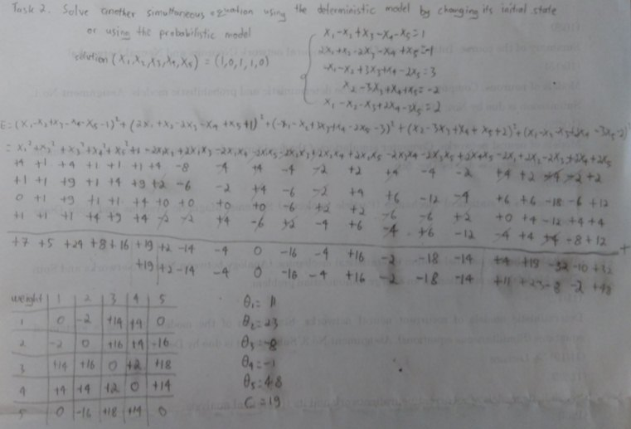

Initial input: (0,1,0,0,1) – opposite to the result | Initial input (1,1,1,1,1)
Result:  --(0,1,0,0,1) - E=87.0  =================================================  -change node 1  --S=-2.0  --(0,1,0,0,1) - E=87.0  =================================================  -change node 2  --S=-16.0  --(0,0,0,0,1) - E=48.0  =================================================  -change node 3  --S=18.0  --(0,0,1,0,1) - E=22.0  =================================================  -change node 4  --S=16.0  --(0,0,1,1,1) - E=4.0  =================================================  -change node 5  --S=32.0  --(0,0,1,1,0) - E=-12.0  =================================================  -change node 1  --S=18.0  --(1,0,1,1,0) - E=-19.0  =================================================  -change node 2 – 1st same value  --S=18.0  --(1,0,1,1,0) - E=-19.0  =================================================  -change node 3 – 2nd same value  --S=16.0  --(1,0,1,1,0) - E=-19.0  =================================================  -change node 4 – 3rd same value  --S=6.0  --(1,0,1,1,0) - E=-19.0  =================================================  -change node 5 – 4th same value  --S=32.0  --(1,0,1,1,0) - E=-19.0  =================================================  -change node 1 – 5th same value  --S=18.0  --(1,0,1,1,0) - E=-19.0  =================================================  -change node 2 – 6th same value  --S=18.0  --(1,0,1,1,0) - E=-19.0  =================================================  =======================END=======================  ================================================= | Result:  --(1,1,1,1,1) - E=18.0  =================================================  -change node 1  --S=16.0  --(1,1,1,1,1) - E=18.0  =================================================  -change node 2  --S=2.0  --(1,0,1,1,1) - E=-3.0  =================================================  -change node 3  --S=34.0  --(1,0,1,1,1) - E=-3.0  =================================================  -change node 4  --S=20.0  --(1,0,1,1,1) - E=-3.0  =================================================  -change node 5  --S=32.0  --(1,0,1,1,0) - E=-19.0  =================================================  -change node 1 – 1st same value  --S=18.0  --(1,0,1,1,0) - E=-19.0  =================================================  -change node 2 – 2nd same value  --S=18.0  --(1,0,1,1,0) - E=-19.0  =================================================  -change node 3—3rd same value  --S=16.0  --(1,0,1,1,0) - E=-19.0  =================================================  -change node 4 – 4th same value  --S=6.0  --(1,0,1,1,0) - E=-19.0  =================================================  -change node 5 – 5th same value  --S=32.0  --(1,0,1,1,0) - E=-19.0  =================================================  -change node 1 – 6th same value  --S=32.0  --(1,0,1,1,0) - E=-19.0  =================================================  =======================END=======================  =================================================
After a few tries, I didn’t get any local minimum problem in this task.

